Lab 1. Your First Bootloader (10 marks)

Understanding how a bootloader works will help you to understand the booting process of a computer. It is important to know what kind of work has been down by the BIOS before the bootloader is invoked.

To understand what happens after the power button or the reset button (we will not discuss the differences between these two modes.) is pressed, you could read this article:

<https://technoguruamit.com/bios-and-booting-process-of-computer/>

or this document (master_boot_record.pdf).

Now let’s try to make a simple bootloader to see how the BIOS will invoke the bootloader automatically and how should we put the bootloader at a specific physical memory location(07C00H).

Please read this book(os-dev.pdf) from the beginning to the Section “3.4.3 Defining Strings”.

**Exercise 1: (6 marks)**

Write a simple bootloader to print out a welcome message(3 marks)stored in memory(3 marks).

Use qemu to start your system.

The command will be like:

**[vm]$ qemu-system-i386 your-bootloader.bin**

**Exercise 2: (4 marks)**

Make a floppy disk image based on your binary file. Use the floppy disk image file to boot a new virtual machine.

You could use the linux command “dd” to create the image file.

The command will be something like:

**[**vm**]** $ dd conv=sync if=your-bootloader.bin of=boot.img bs=1440k count=1

And then you could create the new virtual machine in VirtualBox and set the img file as the floppy disk.

The virtual machine settings will be like the following images.

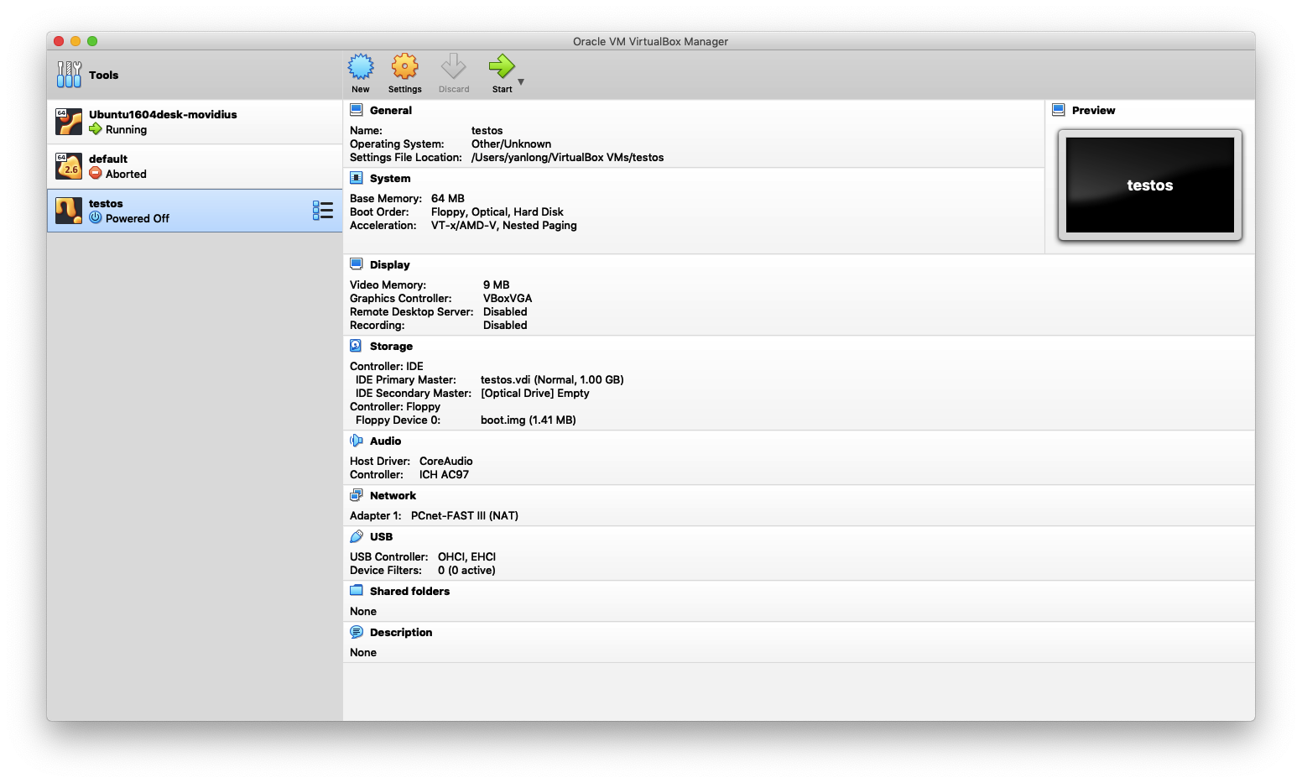

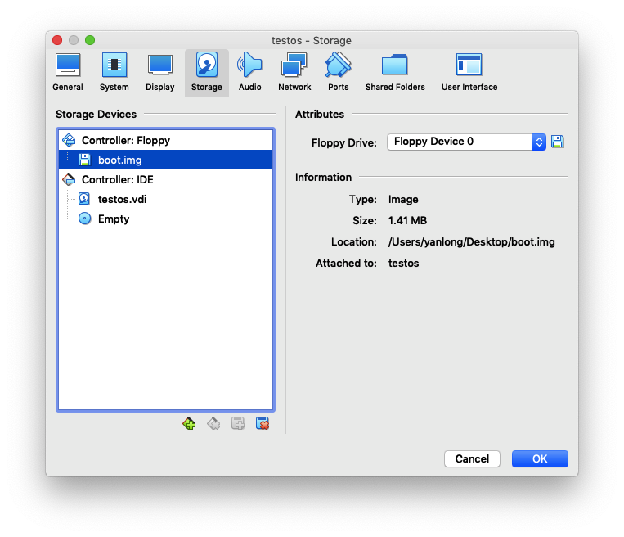

**How to submit?**

Please make a ppt to present your lab work. Please record voiceover (录制旁白) to explain the steps and important codes of your lab.

Make your presentation less than 3 minutes.

Following is a link on how to record voiceover in PowerPoint:

[**https://www.howtogeek.com/449836/how-to-record-voiceover-narration-in-powerpoint/**](https://www.howtogeek.com/449836/how-to-record-voiceover-narration-in-powerpoint/)

**Now you can submit your ppt to the course system.**